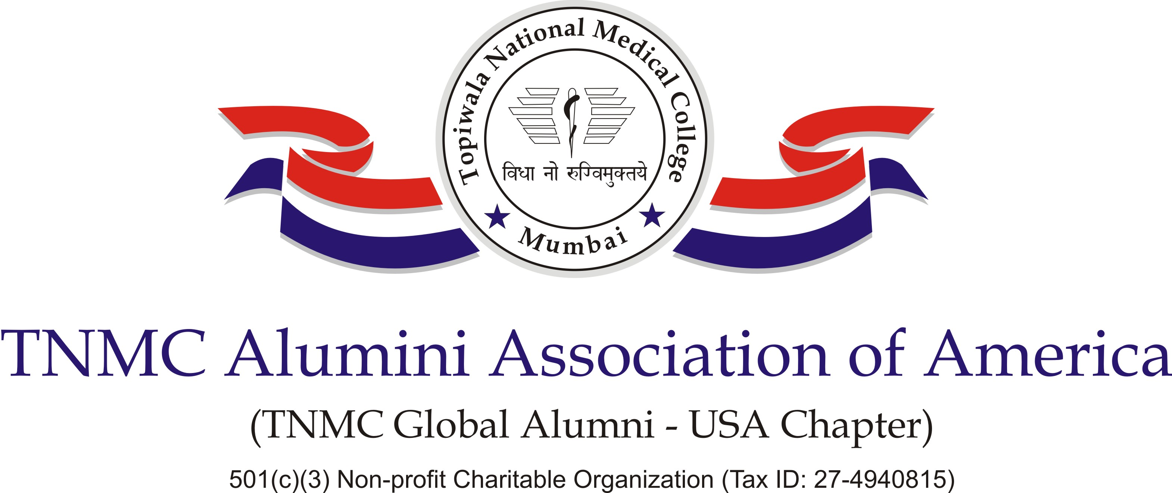

Thank you for your generous support…

Payment by Check:
Please print this form, and fill out the required information along with the check/cashier check /money order made payable to TNMC Alumni Association of America
Mail to:
Donations
TNMC Alumni Association of America
110 Covington Court, Oak Brook, IL 60523

Name: _________________________________________________________________
Address: _______________________________________________________________
City: ____________________ State: ______________ Zip: ___________
Cell Phone: _________________________ Email: ______________________________
TNMC Year of Entry: ________
I would like to donate $________________

The TNMC Alumni Association is a 501(c)(3) Non profit Charitable Organization (Tax ID 27-4940815).

All donations are processed in US dollars and are tax-deductible in the United States. Letter of tax-deductible donation are emailed to donors by January of the following year.

Thank you for your generous support.
If you have any questions or have difficulty in donation process, please contact us at
Email: info@tnmcusa.org / tnmcalumniusa@gmail.com
Phone: +1-312-373 0209

